**Uttar Pradesh**

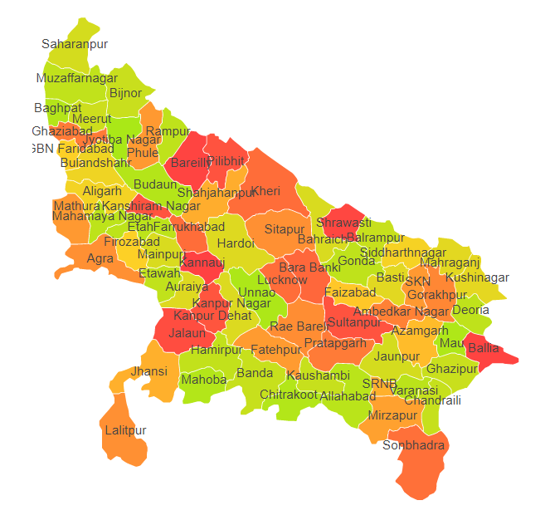

Uttar Pradesh comprises of four Agro Ecological Regions (AER) 4,9,11 & 13.

**Agro-Eco Region 4:** AER 4 in Uttar Pradesh comprises of Agra, Aligarh, Allahabad, Amethi, Auraiya, Baghpat, Banda, Badaun, Bulandsahar, Chitrakoot, Etah, Etawah, Fatehpur, Farrukhabad, Firozabad, Gautambudhnagar, Ghaziabad, Jyotibaphule Nagar, Mahamayanagar, Mainpuri, Mathura, Meerut, Muzafarnagar, Kanshiramnagar, Moradabad, Hardoi, Jalaun, Jaunpur, Kannauj, Kanpur, Kanpur Dehat, Kaushambi, Pratapgarh, Santravidasnagar, Shahjahanpur, Unnao, Varanasi, Raibeareli, Lucknow, Mahoba , Hamirpur, Jhansi and Lalitpur districts of Northern Plain and Central highlands including Aravallis under Agro Ecological Sub Regions (AESR) 4.1, 4.3 & 4.4.

**Agro-Eco Region 9:** AER 9 in Uttar Pradesh comprises of Amethi, Ambedkarnagar, Azamgarh, Ballia, Barabanki, Bareilly, Bijnor, Chandauli, Faizabad, Gazipur, Hardoi , Jyotibaphule Nagar, Jaunpur, Kheri, Lucknow, Mau, Muzafarnagar, Moradabad, Pilhibhit, Rampur, Sharanpur, Shahjahanpur, Sitapur, Sultanpur and Varanasi districts of Northern Plain under Agro Ecological Sub Regions (AESR) 9.1 & 9.2.

**Agro-Eco Region 11:** AER 11 in Uttar Pradesh comprises of Mirzapur, Sonbhadra and Varanasi districts of Eastern Plateau (Chhattisgarh) under Agro Ecological Sub Regions (AESR) 11.

**Agro-Eco Region 13:** AER 13 in Uttar Pradesh comprises of Ambedkar nagar, Bahraich, Balrampur, Basti, Deoria, Gonda, Gorakhpur, Kheri, Kushinagar, Maharajganj, Santkabirnagar, Shrawasti and Siddharthnagar districts of Eastern Plateau (Chhattisgarh) under Agro Ecological Sub Regions (AESR) 13.1 & 13.2.